MERRIMACK VALLEY LEAGUE / RIVER VALLEY LEAGUE
PRESENTS
ANNUAL YOUTH COACHES CLINIC 2016
SATURDAY NOVEMBER 5TH 8:30 AM
(Doors Open at 8:00 am complimentary coffee/donuts)
Ryan School 135 Pleasant Street Tewksbury Ma. 01876

PRESENTERS:

MATT REGAN: Head Coach Bishop Guertin High School
“Drills and discussion on developing youth players and teams”
BERT HAMMEL: Former Merrimack College Head Coach
“Teaching Man 2 Man Defense”
MEG RYAN: Head Coach North Andover High School
“Basics of Read and React Offense”
BILL BOUTILIER: IAABO STATE INTERPRETER
“Ask the Ref – Points of Emphasis and Rules Q & A”
ALSO
SPECIAL PRESENTATION TO ALL 4TH / 5TH GRADE COACHES @ 12:00PM
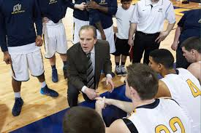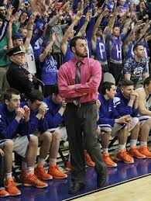
To reserve your spot please email Rick Gorman @ fullctd@aol.com Free to all League Coaches

