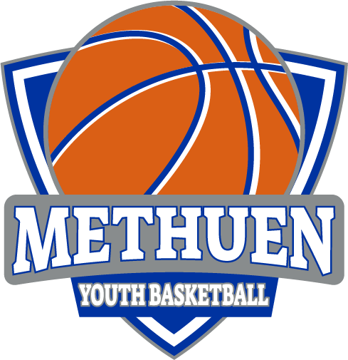

Free Skills and Drills!!!
Special Guest Coach Corey Lowe
Sun 1/29/23 9:00-11:00 AM Tenney Large Gym
Coach won a D1 State Title @ Newton North
Received a D1 Scholarship to B.U.
Graduated as B.U.’s all-time leader in 3pters
Owner of Full Circle Athletics
Current Woman’s HC @ Bradford Christian Academy
Director of Mass Rivals AAU Program

